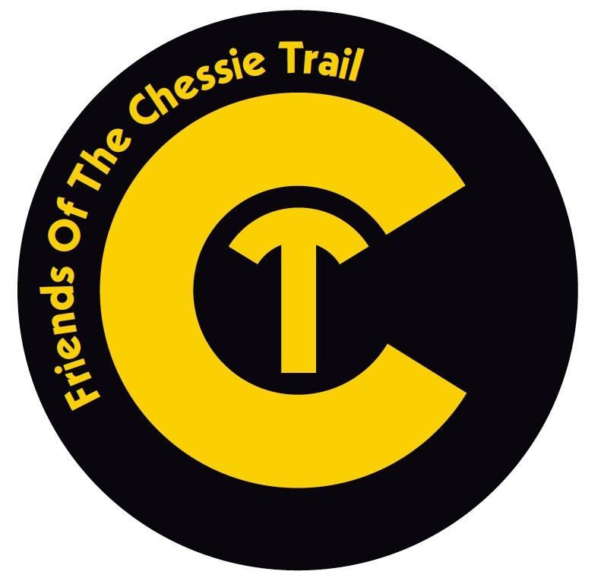
FRIENDS OF THE CHESSIE TRAIL
IS SPONSORING THE 2ND ANNUAL

KIDS FUN RUN!
For Marathoners in “Train-ing”

DISTANCES OF 2.6 MI, 1.3 MI, 1K, AND 0.5K

Sunday, May 15th at 1pm
- FREE!
- Open to runners between PreK and 8th grade.
- All runners will receive a T-shirt and finisher medal with a train logo on them (while supplies last).
- Parents/Guardians must sign waivers and remain at the race site.
- Parking will be limited so please plan ahead.
- Registration is requested but not required.
- To register, volunteer, or get additional information, contact us at chessietrail@gmail.com.

The races will start at the Mill Creek Meadow at the FOCT kiosk. From the stoplight at Veterans Bridge at the north end of Lexington, turn east on Old Buena Vista Road. Drive ½ mile. Parking is available in a lot behind the Pure Oil sign and on both sides of the road. Use caution when parking!

